Review Topics

- Difference between propositional and first-order logic
  - Given a sentance, show that it is valid using a truth table
  - Use of quantifiers
- Searches
- Gameplaying
  - Mini-Max
    - Alpha-Beta
- Genetic Algorithms
  - Construction of a GA
- Exploitation vs. Exploration
- Swarms
  - PSO
  - ANT
- Machine Learning
  - Decision Trees
  - Neural Nets
  - Overfeeding / Memorization
- Clustering
- K-Means
- Philosophy
Artificial Intelligence (AI) is the study of computations that make it possible to perceive, reason, act rationally, behave, learn.

The Imitation Game (Turing Test): a suggested experiment for evaluating whether a system is intelligent. Q. can machines think? Turing restated: can a computer system fool a human into believing
the system is human?

If a machine can't be told apart from a human in a conversation over a teletype, then that's good enough.

Strong vs Weak AI
- Strong AI, is not accomplishable so far that we know of.
- Weak AI are simply problem specific algorithms which are closer to a reaction than true understanding.

Logic

Propositional Logic
- Declarative
- Composional
  - is derived from the individual values ofand
- Context-Independant
- Very limited expressive power
  - Can not say “Pits cause breezes in adjacent square” (from class example)
- Assumes the world contains facts

Truth Table Example:

True | True | True | False | True
True | False | True | True | True
False | True | True | False | True
False | False | False | False | True

First-Order Logic
- Assumes the world contains:
  - Objects
  - Relations (Bigger than, left of, friend, neighbour)
  - Functions
- Atomic Sentences
  - Married(Father(Richard), Mother(John))
- Complex Sentences
  - Any 2 or more atomic sentences joined by a connective

Agents

- PEAS
  - The important aspects of an intelligent agent.
  - Performance Measure, Envirenment, Actuators, Sensors
- Environment Types
  - Fully Observable vs Partially Observable
    - All known training data shows all relevant information (Fully Observable)
    - Noise, innaccuracies, hidden info etc. (Partially Observable)
  - Deterministic vs Stochastic
    - Next state depends on current state (Deterministic)
    - Probabilistic (Stochastic)
  - Episodic vs Sequential
    - Self contained, independent situation (Episodic)
    - Current decision affects future ones (Sequential)
  - Static vs Dynamic
    - Fixed environment vs changing
  - Discrete vs Continuous
    - Finite number of states vs smooth, infinite scale
  - Single Agent vs Multi-Agent
    - One agent vs multiple (adversarial or cooperative)
  - Four basic kind of agents
    - Simple reflex
      - Table-Lookup
    - Model-based reflex
    - Goal-based
      - Extension of Model-Based
    - Utility-based
      - Extension of Model-Based

A Rational Agent is one that does the right thing every time. Rationality does not mean perfection.
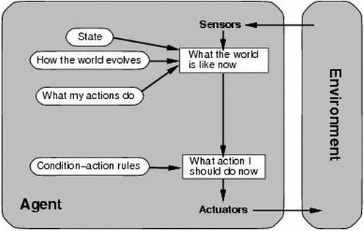Model-Based Reflex Agent
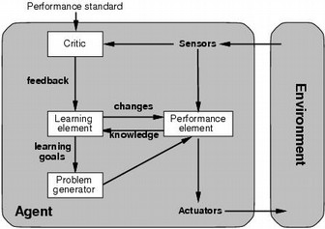Learning Agent
Searches

An algorithm is Complete if it always finishes.
An algorithm is Optimal if it find the shortest path.

- Uninformed (Blind)
  - Breadth First
    - Complete, optimal
    - Memory is an issue
  - Depth-First
    - Neither complete nor optimal
  - Depth-Limited
  - Iterative Deepening
    - Complete, optimal
- Informed
  - Uses a heuristic
    - Considered admissible if it never overestimates the cost to reach the goal.
  - Best-First
    - Nodes are expanded based on some evaluation function
    - Hill-Clmbing
      - May get stuck in local maxima!
      - Simulated Annealing can be used
        - Allows 'bad' moves to be made
  - A*
    - Complete, optimal
      - Avoids expanding paths that are already expensive
      - distance so far + estimated distance left, for example
      - Can be extended to Iterative Deepening to avoid cycles

Gampleplaying

- Minimax
  - Current player is attempting to maximize score
  - Assumes that opponent is trying to minimize current players score
    - Alternating maximizing and minimizing levels in the tree
  - alpha-beta pruning
    - if greatest min being returned is <= to lowest max, you can omit searching the rest of the branches

Genetic Algorithms

Useful for discrete optimization problems.

- Chromosome representation of a problem
  - Population of chromosomes, initialized randomly
  - Selection
    - k-Tournament
  - Crossover
    - n-Point Crossover
    - Order Crossover
      - Crosses a subset from one parent over
      - Fills rest from second in order
    - Uniform-Order Crossover
      - Uses a random mask to copy from first
      - fills rest in order from second
  - Mutation
    - Inversion
    - Insertion
      - Pick a gene, and insert randomly
    - Displacement
      - Pick a subset, and insert it randomly
    - Reciprocal Exchange (Swap)
  - Evaluate

Exploitation vs Exploration

Exploitation
- Mutation for example is exploitative
  - Creating small changes in a chromosome
  - Stays relatively similar to original

Exploration
- Crossover for example is explorative
  - Large changes are made in the chromosome

Swarms

Particle Swarm Optimization
- Particles moving through space freely and continuously keeping track of current and best solutions
- Position represents potential solution
- Best used for continuos optimization problems
  - Can be used for TSP: Use velocity as probability of swap instead of step size

Ant Algorithm
- Population of ants all take seperate paths
  - Leave pheromones, percentage of which is evaporated each generation
  - Most frequently taken paths will have stronger pheromone trails
- Must be able to represent problem in graphical format

Machine Learning

Machine learning is a subfield of AI concerned with programs
that learn from experience

Types of experience:
- Supervised: correct answers for each example
- Unsupervised: correct answers not given
- Reinforcement: occasional rewards

Decision Trees
- Represents a procedure for classifying objects based on attributes
- Internal nodes represent an attribute to test
  - Branches might be yes/no for example
- Leaf nodes represent a classification

Neural Nets
- Feed-Forward
  - All neuron layers are interconnected in a forward direction
  - Values are “fed forward”
- Back-Propogation
  - Learning algorithm which distributes the error of the output backwards based on the learning rate

Dangers of Overfeeding
- Overfeeding a neural net or decision tree may result in memorization
- Memorization will result in a potentially incorrect answer if the net/tree gets something new or unusual as an input.

Clustering

Similar idea to a perceptron, number of neurons is equal to number of clusters

Unsupervised Learning
- Must rely on input data to learn similarities
- Determine clusters and number of them on the fly

k-Means Algorithm
- Initially, assign k-cluster centers to k randomly chosen chosen instances
- Repeat:
  - Assign each point to it's closest representative
  - Recalculate position of centers

